INDEX

Sl No | Name of the program | Date | Page No | Remarks
1 | Create your class time table using table tag. |  | 2
2 | Design a web Page for your college containing description of courses, department, faculties, library etc. Using list tags, href tags and anchor tags. |  | 4
3 | Create your Resume using HTML. Use text, link, and lists |  | 8
4 | Create a webpage of a supermarket using (internal CSS) . |  | 10
5 | Use Inline CSS to format your resume that you have created. |  | 13
6 | Use External CSS to format your time table created. |  | 15
7 | Use all the CSS (inline, internal, and external) to format the college web page that you have created. |  | 18
8 | Write a HTML program to create your college website for mobile device |  | 22

Program 1
Create your class time table using table tag

Aim
Create your class time table using table tag

Program

<!DOCTYPE html>
<html>
<head>
<title>Class Time Table</title>
<h2 align="centre">BCA 2ND SEM TIMETABLE</h2>
<table border="4" align="centre">
</head>
<tr>
<th></th>
<th>1st</th>
<th>2nd</th>
<th>3rd</th>
<th>4th</th>
<th>5th</th>

</tr>
<tr>
<td>Day 1</td>
<td>DS</td>
<td>OS</td>
<td>ENGLISH</td>
<td colspan="2">WEB LAB</td>
</tr>
<tr>
<td>Day 2</td>
<td>HINDI/MALAYALAM</td>
<td>DS</td>
<td>IC</>
<td>MATHS</td>
<td>OS</td>
</tr>
<tr>
<td>Day 3</td>

<td>DS</td>
<td>ENGLISH</td>
<td>HINDI/MALAYALAM</td>
<td>OS</td>
<td>MATHS</td>
</tr>
<tr>
<td>Day 4</td>
<td>OS</td>
<td>DS</td>
<td>ENGLISH</td>
<td>MATHS</td>
<td>HINDI/MALAYALAM</td>
</tr>
<tr>
<td>Day 5</td>
<td>MATHS</td>
<td>IC</td>
<td>WEB</td>
<td colspan="2">DS LAB</td>
</tr>
</body>
</html>

Output

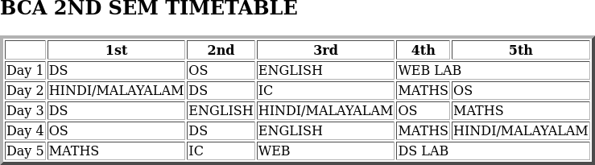

Program 2
Design a web Page for your college containing description of courses, department, faculties, library etc. Using list tags, href tags, and anchor tags.

Aim
Design a web Page for your college containing description of courses, department, faculties, library etc. Using list tags, href tags, and anchor tags.

Program

<!DOCTYPE html>

<head>
<title>college</title>
</head

<body>
<h2>ST.GEORGE'S COLLEGE ARUVITHURA</h2>
<p><strong>St. George's College Aruvithura</strong> is a college under Mahatma Gandhi University, Kottayam. It is located in Aruvithura, Erattupetta, Kottayam District in Kerala, India. It was reaccredited with'<strong>A++</strong>' Grade by NAAC for seven years in the fourth cycle.
<img src="clgpic.jpg" height="350" width="650"alt="college image">
<p>St. George’s College Aruvithura, is a minority educational institution founded by St. George Forane Church, Aruvithura in 1965. Pioneered under the patronage of His Excellency Mar Sebastian Vayalil, the first Bishop of Pala, and cherished by a host of visionaries and philanthropists like Very Rev. Fr. Thomas Araythinal and Mr T. A. Thomman (Former Minister), the college, right from its inception, embarked on an odyssey towards academic pre-eminence. Very Rev. Fr. Thomas Manakkat, the founding manager and a great visionary, was truly instrumental in laying the foundations for a great beginning and Very Rev. Fr. Jacob Thazhathel, who followed him, was equally adept and insightful in his ideals, guiding the college during the early stages of its growth. For more than two decades, His Excellency Mar Joseph Pallickaparampil, the Bishop of Pala, had been the patron of the college. His Excellency Mar Joseph Kallarangattu is the present patron of this seat of learning.</p>
<h3>PROGRAMMES</h3>
<ol>
<li>UG</li>
<li>PG</li>
<li>PhD</li>
<li>Open Course</li>
<li>Certificate Course</li>

</ol>
<h3>COURSES OFFERED</h3>
<h4>Aided</h4>
<ol>

</ol>
<li>B.sc(Honours)Mathematics</li>
<li>B.sc(Honours)Physics</li>
<li>B.sc(Honours)Chemistry</li>
<li></li>
<li>B.sc(Honours)Botany</li>
<li>B.sc(Honours)Polotical Science</li>
<li>B.A(Honours)English With Specialization in Media Studies & Film Studies</li>
<li>BCA(Honours)With Specialization in Data Science & Full Stack Development</li>
<li>B.Com(Honours)With Specialization in Finance & Taxation</li>

<h4>self</h4>
<ol>
<li>B.Com(Honours)With Specialization in Finance & Taxation</li>
<li>B.Com(Honours)With Specialization in Finance and Taxation & Accounting </li>
<li>B.Com (Honours) with Specialization in Financial Markets & Logistics Management</li>
<li>B.Com (Honours) with Specialization in Co-Operation & Accounting</li>
<li>B.A (Honours) Journalism & Mass Communication</li>
<li>B.Sc (Honours) Food Science & Quality Control with specialization in Food Saftey</li>
<li>B.Voc Food Technology & Analysis</li>
<li>BCA (Honours) with Specialization in Artificial Intelligence and Machine Learning & Full Stack Devel</li>
</ol>
<h3>DEPARTMENTS</h3>
<ol>

</ol>
<li>Department of Botany and Zoology</li>
<li>Department of Chemistry </li>
<li>Department of Commerce</li>
<li>Department of Computer Applications</li>
<li>Department of Economics</li>
<li>Department of English</li>
<li>Department of Food Science and Technology</li>
<li>Department of Hindi and Malayalam</li>
<li>Department of Mathematics and Statistics</li>
<li>Department of Physics</li>
<li>Department of Political Science and History</li>

<h3>FACULTIES</h3>
<ul>
<li><a href="">Department of Botany and Zoology</a></li>
<li><a href="">Department of Chemistry</a></li>
<li><a href="">Department of Commerce</a></li>

<li><a href="">Department of Computer Applications</a></li>
<li><a href="">Department of Economics</a></li>
<li><a href="">Department of English</a></li>
<li><a href="">Department of Food Science and Technology</a></li>
<li><a href="">Department of Hindi and Malayalam</a></li>
<li><a href="">Department of Mathematics and Statistics</a></li>
<li><a href="">Department of Physics</a></li>
<li><a href="">Department of Political Science and History</a></li>
</ul>
<h3>LIBRARY</h3>
</body>
<li><a href="https://sgcaruvithura.ac.in/library">Library</a></li></ul>
Visit here for more details..<a href="https://sgcaruvithura.ac.in/index.html">College website</a>
</html>

Output
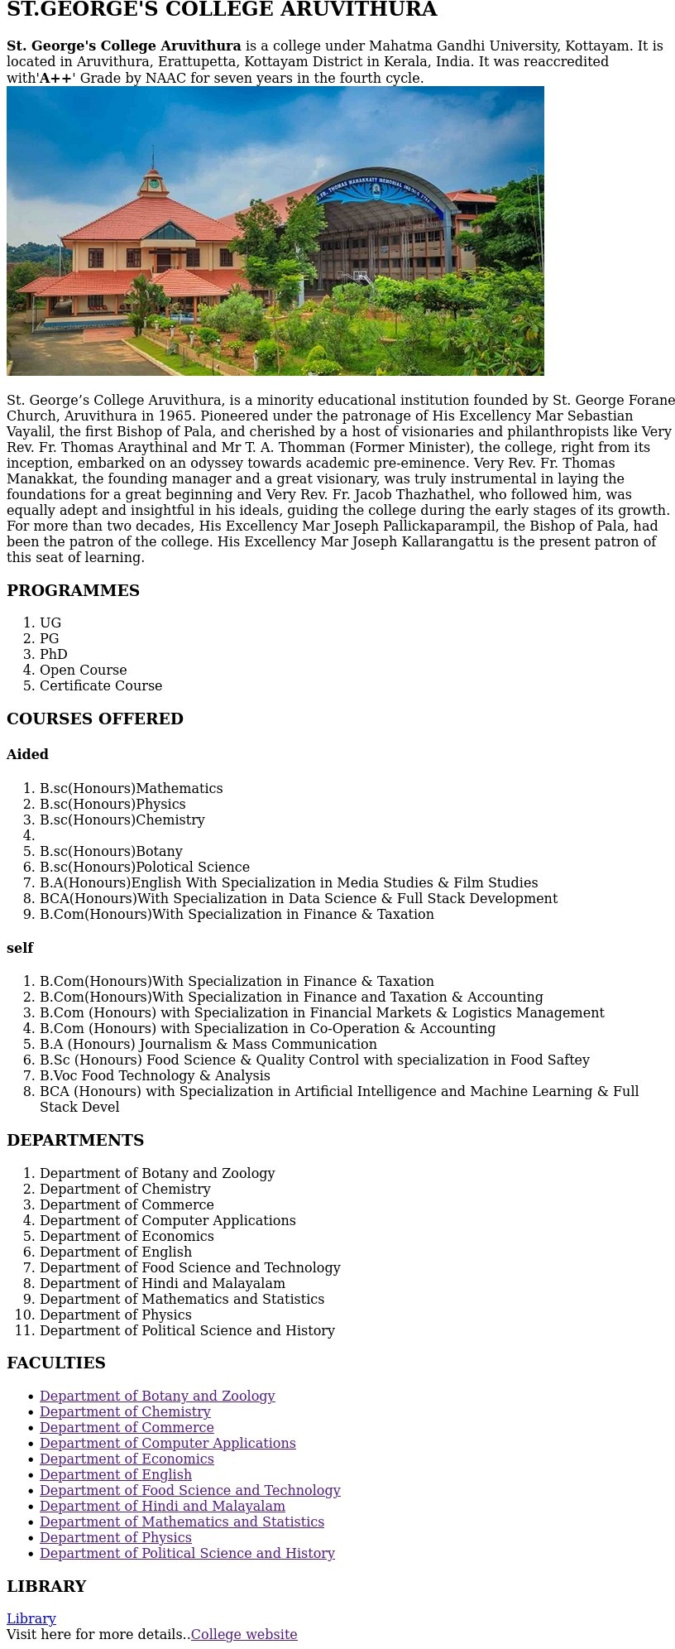

Program 3
Create your resume using HTML. Use text, link and lists.

Aim
Create your resume using HTML. Use text, link and lists.

Program

<!DOCTYPE html>
<html>
<head>
<title>Resume</title>

</head>
<body>
<h1 align="centre">FATHIMA RINSHI TV</h1>
<p align="centre">
Email:<a href="rinshitv.koolimadu@gmail.com">rinshitv.koolimadu@gmail.com</a><br>
<p>phone:9746830266<br></p>
<p>DOB:22/08/2006</p>
<h3>EDUCATIONAL QUALIFICATIONS</h3>
<ul>

<p><li>Bachelors of Computer Application(St.GEORGES COLLEGE ARUVITHURA)</p</li><br>
<li>Higher Secondary passed<br>(CMR HSS KOZHIKODE)</li>
<li>SSLC passed(CMR HS KOZHIKODE).</li>

<h4>CAREER OBJECTIVES</h4>

<p>To secure a challenging role in software development where i can apply my programming skills to contribute to organisational growth and personal development.</p>
</ul>

<h4>SKILLS</h4>
<ul>
<li><b>Programming</b>:C/C++,Javascript.</li>
<li>Good Typing skill.</li>
<li>Strong analytical and problem solving skills.</li>
</ul>
<h4>HOBBIES</h4>

<ul>
<li>Reading</li>
<li>drawing</li>
<li>singing</li>
</ul>

</body>
</html>

Output
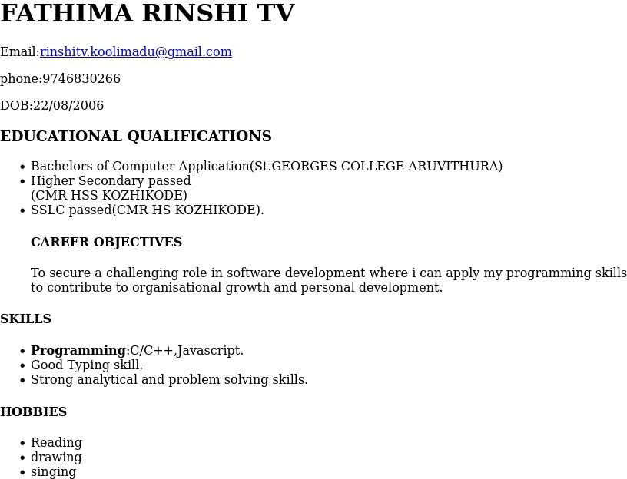

Program 4
Create a Web page of a supermarket using(internal CSS).

Aim
Create a Web page of a supermarket using(internal CSS).

Program

<!DOCTYPE html>

<html>
<head>
<title>Supermarket</title>

</head>
<style> h1{
color:maroon; font-size:30px;
}
h3{
color:purple; font-size:22px
}
</style>
<body>
<h1><u>SUPER MARKET</u></h1>
<h2><u>PRODUCT LIST</u><h2>
<h3><u>GROCERIES</u></h3>
<ol>
<li>RICE</li>
<li>SUGAR</li>
<li>FLOUR</li>
<li>MILK</li>
<li>NUTS</li>
<li>CURRY POWDERS</li>
</ol>

<h3><u>VEGETABLES</u></h3>
<ol>
<li>TOMATO</li>

<li>CABBAGE</li>
<li>CHILLI</li>
<li>POTATO</li>
<li>ONOIN</li>
<li>CUCUMBER</li>
</ol>
<h3><u>FRUITS</u></h3>
<ol>
<li>APPLE</li>
<li>BANANA</li>
<li>PAPAYA</li>
<li>BERRIES</li>
<li>DATES</li>
<li>MANGO
<ul>
<li>RIPE</li>
<li>RAW</li>
</ul>
<li>WATERMELON</li>
<li>GRAPES</li>
<ul>
<li>RIPE</li>
<li>RAW</li>
</ul>
</li>
</ol>
<h3><u>BAKERY</u></h3>
<ol>
<li>BISCUITS</li>
<li>CAKES</li>
<li>COOKIES</li>
<li>CHIPS</li>
<li>SWEETS</li>
</ol>
</body>
</html>

Output
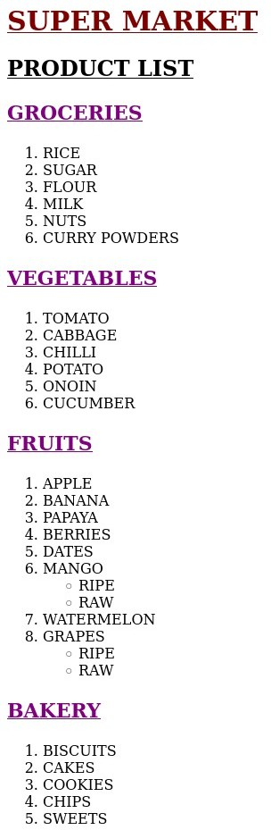

Program 5
Use Inline CSS to format your resume that you have created .

Aim
Use Inline CSS to format your resume that you have created

Program

<!DOCTYPE html>
<html>
<head>
<title>Resume</title>

</head>
<body>
<h1 align="centre">FATHIMA RINSHI TV</h1>
<p align="centre">
Email:<a href="rinshitv.koolimadu@gmail.com">rinshitv.koolimadu@gmail.com</a><br>
<p>phone:9746830266<br></p>
<p>DOB:22/08/2006</p>
<h3>EDUCATIONAL QUALIFICATIONS</h3>
<ul>

<h4>St.Georges college Aruvithura</h4>
<p>Bachelors of Computer Application</p><br>
<li>Higher Secondary passed<br>(CMR HSS KOZHIKODE)</li>
<li>SSLC passed(CMR HS KOZHIKODE).</li>

<h4>CAREER OBJECTIVES</h4>

<p style="color:brown; font-size:18px;">To secure a challenging role in software development where i can apply my programming skills to contribute to organisational growth and personal development.</p>
</ul>

<h4>SKILLS</h4>
<ul>
<li><b>Programming</b>:C/C++,Javascript.</li>
<li>Good Typing skill.</li>
<li>Strong analytical and problem solving skills.</li>


</ul>
<h4>HOBBIES</h4>
<ul>
<li>Reading</li>
<li>drawing</li>
<li>singing</li>
</ul>
</body>
</html>

Output

Program 6
Use External CSS to format your time table created.

Aim
Create your resume using HTML. Use text, link and lists.

Program

<!DOCTYPE html>
<html>
<head>
<link rel="stylesheet" href="style2.css">
<title>Class Time Table</title>
<h2 align="centre">BCA 2ND SEM TIMETABLE</h2>
<table border="4" align="centre">
</head>
<tr>
<th></th>
<th>1st</th>
<th>2nd</th>
<th>3rd</th>
<th>4th</th>
<th>5th</th>

</tr>
<tr>
<td>Day 1</td>
<td>DS</td>
<td>OS</td>
<td>ENGLISH</td>
<td colspan="2">WEB LAB</td>
</tr>
<tr>
<td>Day 2</td>
<td>HINDI/MALAYALAM</td>
<td>DS</td>
<td>IC</>
<td>MATHS</td>
<td>OS</td>
</tr>
<tr>

<td>Day 3</td>
<td>DS</td>
<td>ENGLISH</td>
<td>HINDI/MALAYALAM</td>
<td>OS</td>
<td>MATHS</td>
</tr>
<tr>
<td>Day 4</td>
<td>OS</td>
<td>DS</td>
<td>ENGLISH</td>
<td>MATHS</td>
<td>HINDI/MALAYALAM</td>
</tr>
<tr>
<td>Day 5</td>
<td>MATHS</td>
<td>IC</td>
<td>WEB</td>
<td colspan="2">DS LAB</td>
</tr>
</body>
</html>

style2.css
table
{
color:brown; font-size:19px;
}

Output

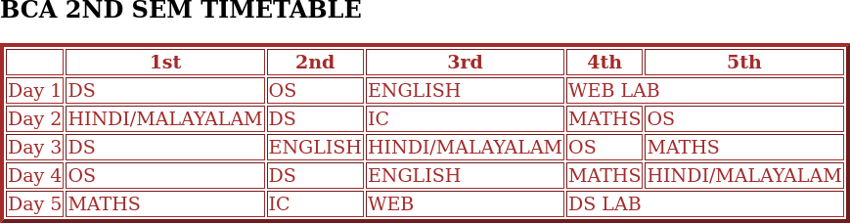

Program 7
Use all the CSS (inline,internal and external) to format the college web page that
you have created.

Aim
Use all the CSS (inline,internal and external) to format the college web page that you have created.

Program

<!DOCTYPE html>

<head>
<link rel="stylesheet" href="style.css">
<title>college</title>
</head>
<style> p{
color:green; font-size:20px;
}
</style>
<body>
<h2>ST.GEORGE'S COLLEGE ARUVITHURA</h2>
<p style="color:red;font-size:18px;"><strong>St. George's College Aruvithura</strong> is a college under Mahatma Gandhi University, Kottayam. It is located in Aruvithura, Erattupetta, Kottayam District in Kerala, India. It was reaccredited with'<strong>A++</strong>' Grade by NAAC for seven years in the fourth cycle.
<img src="clgpic.jpg" height="350" width="650"alt="college image">
<p>St. George’s College Aruvithura, is a minority educational institution founded by St. George Forane Church, Aruvithura in 1965. Pioneered under the patronage of His Excellency Mar Sebastian Vayalil, the first Bishop of Pala, and cherished by a host of visionaries and philanthropists like Very Rev. Fr. Thomas Araythinal and Mr T. A. Thomman (Former Minister), the college, right from its inception, embarked on an odyssey towards academic pre-eminence. Very Rev. Fr. Thomas Manakkat, the founding manager and a great visionary, was truly instrumental in laying the foundations for a great beginning and Very Rev. Fr. Jacob Thazhathel, who followed him, was equally adept and insightful in his ideals, guiding the college during the early stages of its growth. For more than two decades, His Excellency Mar Joseph Pallickaparampil, the Bishop of Pala, had been the patron of the college. His Excellency Mar Joseph Kallarangattu is the present patron of this seat of learning.</p>

<h3>PROGRAMMES</h3>
<ol>

</ol>
<li>UG</li>
<li>PG</li>
<li>PhD</li>
<li>Open Course</li>
<li>Certificate Course</li>

<h3>COURSES OFFERED</h3>
<h4>Aided</h4>
<ol>

</ol>
<li>B.sc(Honours)Mathematics</li>
<li>B.sc(Honours)Physics</li>
<li>B.sc(Honours)Chemistry</li>
<li></li>
<li>B.sc(Honours)Botany</li>
<li>B.sc(Honours)Polotical Science</li>
<li>B.A(Honours)English With Specialization in Media Studies & Film Studies</li>
<li>BCA(Honours)With Specialization in Data Science & Full Stack Development</li>
<li>B.Com(Honours)With Specialization in Finance & Taxation</li>

<h4>self</h4>
<ol>
<li>B.Com(Honours)With Specialization in Finance & Taxation</li>
<li>B.Com(Honours)With Specialization in Finance and Taxation & Accounting </li>
<li>B.Com (Honours) with Specialization in Financial Markets & Logistics Management</li>
<li>B.Com (Honours) with Specialization in Co-Operation & Accounting</li>
<li>B.A (Honours) Journalism & Mass Communication</li>
<li>B.Sc (Honours) Food Science & Quality Control with specialization in Food Saftey</li>
<li>B.Voc Food Technology & Analysis</li>
<li>BCA (Honours) with Specialization in Artificial Intelligence and Machine Learning & Full Stack Devel</li>
</ol>
<h3>DEPARTMENTS</h3>
<ol>
<li>Department of Botany and Zoology</li>
<li>Department of Chemistry </li>
<li>Department of Commerce</li>
<li>Department of Computer Applications</li>
<li>Department of Economics</li>
<li>Department of English</li>
<li>Department of Food Science and Technology</li>
<li>Department of Hindi and Malayalam</li>
<li>Department of Mathematics and Statistics</li>
<li>Department of Physics</li>

<li>Department of Political Science and History</li>
</ol>
<h3>FACULTIES</h3>
<ul>
<li><a href="">Department of Botany and Zoology</a></li>
<li><a href="">Department of Chemistry</a></li>
<li><a href="">Department of Commerce</a></li>
<li><a href="">Department of Computer Applications</a></li>
<li><a href="">Department of Economics</a></li>
<li><a href="">Department of English</a></li>
<li><a href="">Department of Food Science and Technology</a></li>
<li><a href="">Department of Hindi and Malayalam</a></li>
<li><a href="">Department of Mathematics and Statistics</a></li>
<li><a href="">Department of Physics</a></li>
<li><a href="">Department of Political Science and History</a></li>
</ul>
<h3>LIBRARY</h3>
</body>
<li><a href="https://sgcaruvithura.ac.in/library">Library</a></li></ul>
Visit here for more details..<a href="https://sgcaruvithura.ac.in/index.html">College website</a>
</html>

style.css

h3
{
color:brown; font-size:22px;
}

Output
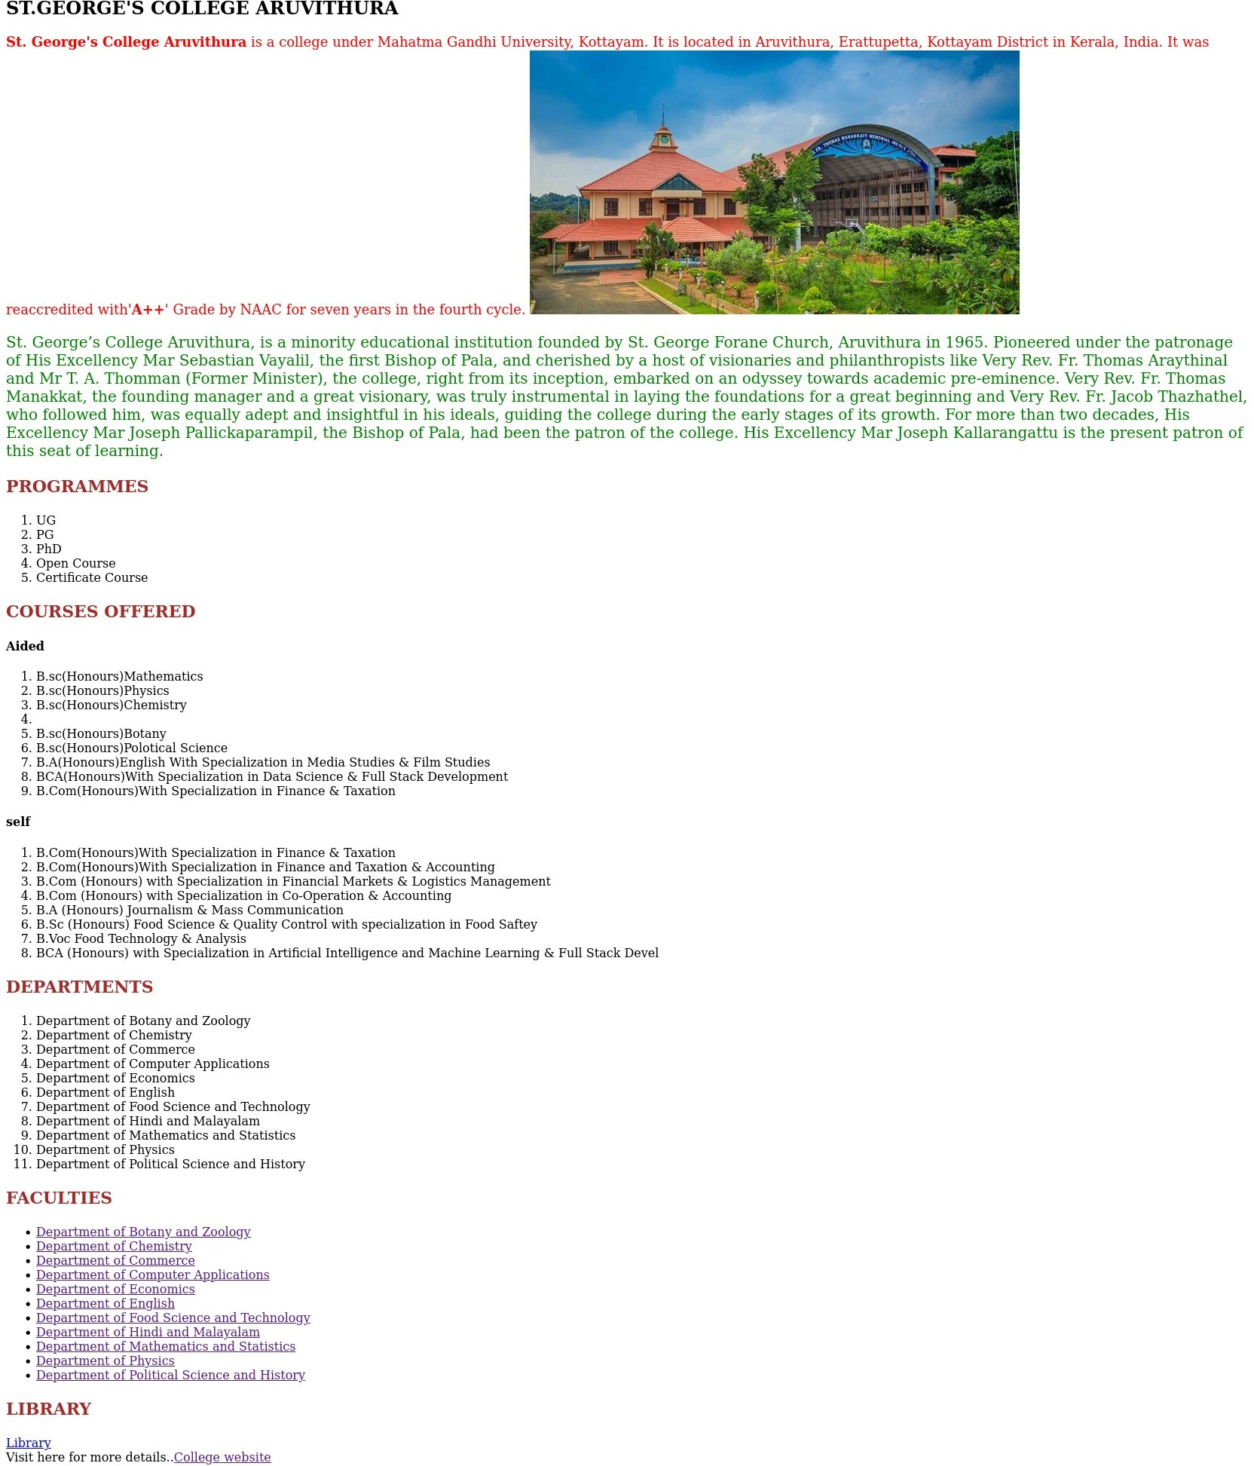

Program 8
Write a HTML program to create your college website for mobile device

Aim
Write a HTML program to create your college website for mobile device

Program
<!DOCTYPE html>

<head>
<meta name="view port" content="width=device-width,initial-scale=1.0">
<link rel="stylesheet" href="style.css">
<title>college</title>
</head>
<style> p{
color:green; font-size:20px;
}
</style>
<body>
<h2>ST.GEORGE'S COLLEGE ARUVITHURA</h2>
<p style="color:red;font-size:18px;"><strong>St. George's College Aruvithura</strong> is a college under Mahatma Gandhi University, Kottayam. It is located in Aruvithura, Erattupetta, Kottayam District in Kerala, India. It was reaccredited with'<strong>A++</strong>' Grade by NAAC for seven years in the fourth cycle.
<img src="clgpic.jpg" height="300" width="350"alt="college image">
<p>St. George’s College Aruvithura, is a minority educational institution founded by St. George Forane Church, Aruvithura in 1965. Pioneered under the patronage of His Excellency Mar Sebastian Vayalil, the first Bishop of Pala, and cherished by a host of visionaries and philanthropists like Very Rev. Fr. Thomas Araythinal and Mr T. A. Thomman (Former Minister), the college, right from its inception, embarked on an odyssey towards academic pre-eminence. Very Rev. Fr. Thomas Manakkat, the founding manager and a great visionary, was truly instrumental in laying the foundations for a great beginning and Very Rev. Fr. Jacob Thazhathel, who followed him, was equally adept and insightful in his ideals, guiding the college during the early stages of its growth. For more than two decades, His Excellency Mar Joseph Pallickaparampil, the Bishop of Pala, had been the patron of the college. His Excellency Mar Joseph Kallarangattu is the present patron of this seat of learning.</p>
<h3>PROGRAMMES</h3>

<ol>

</ol>

<li>UG</li>
<li>PG</li>
<li>PhD</li>
<li>Open Course</li>
<li>Certificate Course</li>

<h3>COURSES OFFERED</h3>
<h4>Aided</h4>
<ol>

</ol>
<li>B.sc(Honours)Mathematics</li>
<li>B.sc(Honours)Physics</li>
<li>B.sc(Honours)Chemistry</li>
<li></li>
<li>B.sc(Honours)Botany</li>
<li>B.sc(Honours)Polotical Science</li>
<li>B.A(Honours)English With Specialization in Media Studies & Film Studies</li>
<li>BCA(Honours)With Specialization in Data Science & Full Stack Development</li>
<li>B.Com(Honours)With Specialization in Finance & Taxation</li>

<h4>self</h4>
<ol>
<li>B.Com(Honours)With Specialization in Finance & Taxation</li>
<li>B.Com(Honours)With Specialization in Finance and Taxation & Accounting </li>
<li>B.Com (Honours) with Specialization in Financial Markets & Logistics Management</li>
<li>B.Com (Honours) with Specialization in Co-Operation & Accounting</li>
<li>B.A (Honours) Journalism & Mass Communication</li>
<li>B.Sc (Honours) Food Science & Quality Control with specialization in Food Saftey</li>
<li>B.Voc Food Technology & Analysis</li>
<li>BCA (Honours) with Specialization in Artificial Intelligence and Machine Learning & Full Stack Devel</li>
</ol>
<h3>DEPARTMENTS</h3>
<ol>
<li>Department of Botany and Zoology</li>
<li>Department of Chemistry </li>
<li>Department of Commerce</li>
<li>Department of Computer Applications</li>
<li>Department of Economics</li>
<li>Department of English</li>
<li>Department of Food Science and Technology</li>
<li>Department of Hindi and Malayalam</li>
<li>Department of Mathematics and Statistics</li>
<li>Department of Physics</li>
<li>Department of Political Science and History</li>

</ol>
<h3>FACULTIES</h3>
<ul>
<li><a href="">Department of Botany and Zoology</a></li>
<li><a href="">Department of Chemistry</a></li>
<li><a href="">Department of Commerce</a></li>
<li><a href="">Department of Computer Applications</a></li>
<li><a href="">Department of Economics</a></li>
<li><a href="">Department of English</a></li>
<li><a href="">Department of Food Science and Technology</a></li>
<li><a href="">Department of Hindi and Malayalam</a></li>
<li><a href="">Department of Mathematics and Statistics</a></li>
<li><a href="">Department of Physics</a></li>
<li><a href="">Department of Political Science and History</a></li>
</ul>
<h3>LIBRARY</h3>
</body>
<li><a href="https://sgcaruvithura.ac.in/library">Library</a></li></ul>
Visit here for more details..<a href="https://sgcaruvithura.ac.in/index.html">College website</a>
</html>

style.css

h3
{
color:brown; font-size:22px;
}
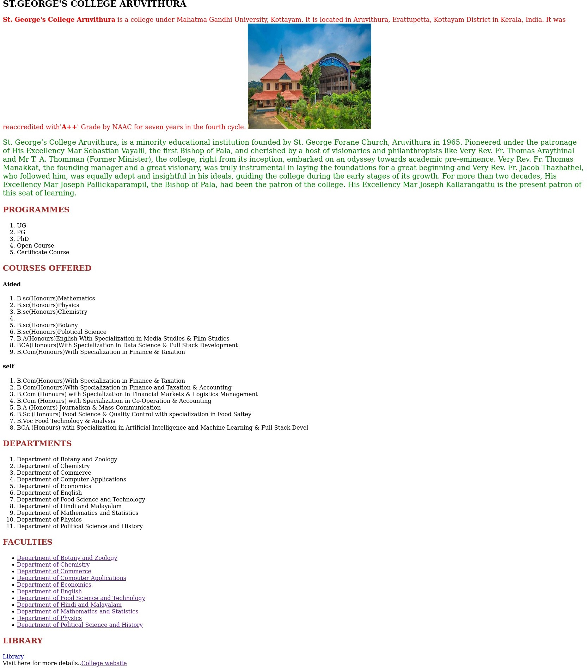
Output

Program 9
Write an HTML/javascript page to create login page with validations.

Aim

Write an HTML/javascript page to create login page with validations.

Program

<!DOCTYPE html>
<html>
<head>
</head>
<body>
Username: <input type="text" id="username" required><br><br>
Password: <input type="password" id="pass" required>
<input type="button" value="Login" id="btn">
<script>
document.getElementById("btn").addEventListener("click", function(){
let name=document.getElementById("username").value;
let pass=document.getElementById("pass").value;
if(name.trim() === "") {
alert("username is required");
return;
};
if(pass.length < 6 || pass.length > 12) {
alert("password must be between 6 and 12 characters");
return;
}
document.write("Login Sucessfull");
});
</script>
</body>
</html>

Output

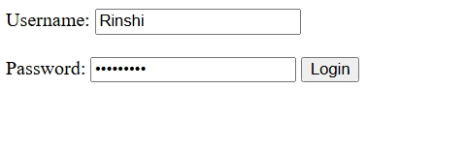


Program 10
Develop a simple calculator for addition, subtraction, multiplication, and
division operation using JavaScript.

Aim

Develop a simple calculator for addition, subtraction, multiplication, and division operation using JavaScript.

Program

<!DOCTYPE html>
<html>
<head>
</head>
<body>
<input type="number" id="num1" placeholder="Enter the fisrt number">
<input type="text" maxlength=1 id="opr" placeholder="Enter the operator">
<input type="number" id="num2" placeholder="Enter the second number">
<input type="button" value="Submit" id="btn">
<p id="out"><p>
<script>
document.getElementById("btn").addEventListener("click", function(){
let x=Number(document.getElementById("num1").value);
let y=document.getElementById("opr").value;
let z=Number(document.getElementById("num2").value);
let otp;
switch(y)
{
case "+":
otp=x+z;
break;
case "-":
otp=x-z;
break;
case "*":
otp=x*z;
break;
case "/":
otp=x/z;
break;
};
document.getElementById("out").innerHTML="Result: " + otp;
});
</script>
</body>
</html>

Output

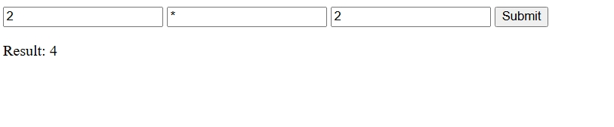

Program 11
Use Regular Expressions for validations in Login Page using JavaScript.

Aim
Use Regular Expressions for validations in Login Page using JavaScript.

Program

<!DOCTYPE html>
<html>
<head>
<title>Login Page</title>
</head>
<body>
Email: <input type="text" id="user" required><br><br>
Password: <input type="password" id="pass" required>
<input type="button" value="Login" id="btn">
<script>
document.getElementById("btn").addEventListener("click", function(){
let email = document.getElementById("user").value;
let pass = document.getElementById("pass").value;

const pattern = /\w+@\w+\.\w+/;

if(!pattern.test(email)) {
alert("Please enter a valid email address");
return;
}
if(pass.length < 6 || pass.length > 12) {
alert("password must be between 6 and 12 characters");
return;
}
document.write("Login Successful");
});
</script>
</body>
</html>

Output

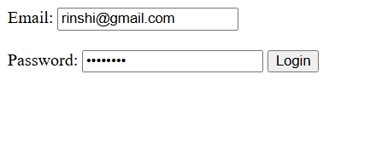


Program 12
Write a Program to retrieve data from a text file and display it using AJAX

Aim

Write a Program to retrieve data from a text file and display it using AJAX

Program

Index2.html

<!DOCTYPE html>
<html>
<head>
<title>AJAX JSON Example</title>
</head>

<body>

<h2>Student List</h2>

<button onclick="loadStudents()">Load Students</button>

<ul id="result"></ul>

<script>

function loadStudents()
{
let xhr = new XMLHttpRequest();

xhr.open("GET", "students.json", true);

xhr.onload = function()
{
let students = JSON.parse(xhr.responseText);

let output = "";

for (let i in students)
{
output += "<li>" + students[i].name +
" - " + students[i].course +
" - " + students[i].mark +
"</li>";
}

document.getElementById("result").innerHTML = output;
};

xhr.send();
}

</script>

</body>
</html>

Student.json

[
{"name": "Arun", "course": "BCA", "mark": 85},
{"name": "Meera", "course": "BCA", "mark": 91},
{"name": "Rahul", "course": "BCA", "mark": 78},
{"name": "Anjali", "course": "BCA", "mark": 88}
]

greet.php

<?php

$name = $_POST['username'];

echo "Hello, " . $name;

?>

Program 13
Create a web page using Frame with rows and columns where we will have header
frame left frame, right frame and status bar frame. On clicking in the left frame,
information should be displayed in the right frame.

Aim
Create a web page using Frame with rows and columns where we will have header frame,
left frame, right frame and status bar frame. On clicking in the left frame, information
should be displayed in the right frame.

Program

